PROJECT DESIGN PHASE
1. Objective
The objective of the Design Phase is to translate the defined requirements into a complete system architecture for the Medical Inventory Management System.
This phase focuses on creating the user interface (UI), process automation logic, security configuration, and analytical dashboards to streamline the management of medical supplies, purchase orders, and stock movements.
Key design focus areas:
- User Interface (Items, Suppliers, Purchase Orders, GRNs, Stock Pages)
- Process Automation (Flows, Approvals, Triggers)
- Security & Role-Based Access
- Real-Time Reporting & Inventory Dashboards
2. Design Overview
The Medical Inventory Management System is designed using Salesforce Lightning Experience, providing an intuitive, cloud-based, and automated inventory solution.
The system design includes:
- Five core objects — Item, Supplier, Purchase Order, Goods Receipt (GRN), Stock Ledger
- Screen Flows for PO creation and GRN entry
- Apex Trigger for auto stock balance update
- Reports & Dashboards for stock status, expiry, and supplier performance
- Role-based data visibility for clerks, managers, and finance users
3. User Interface (UI) Design
3.1 Lightning App Design
A custom Lightning App named “Medical Inventory Management” was created for store and purchase users.
Steps followed:
- Setup → App Manager → New Lightning App
- Added logo, app description, and branding color
- Navigation tabs included:
• Home
• Items
• Suppliers
• Purchase Orders
• Goods Receipts (GRN)
• Stock Ledger
• Issues / Returns
• Reports & Dashboards
Design Principles Applied:
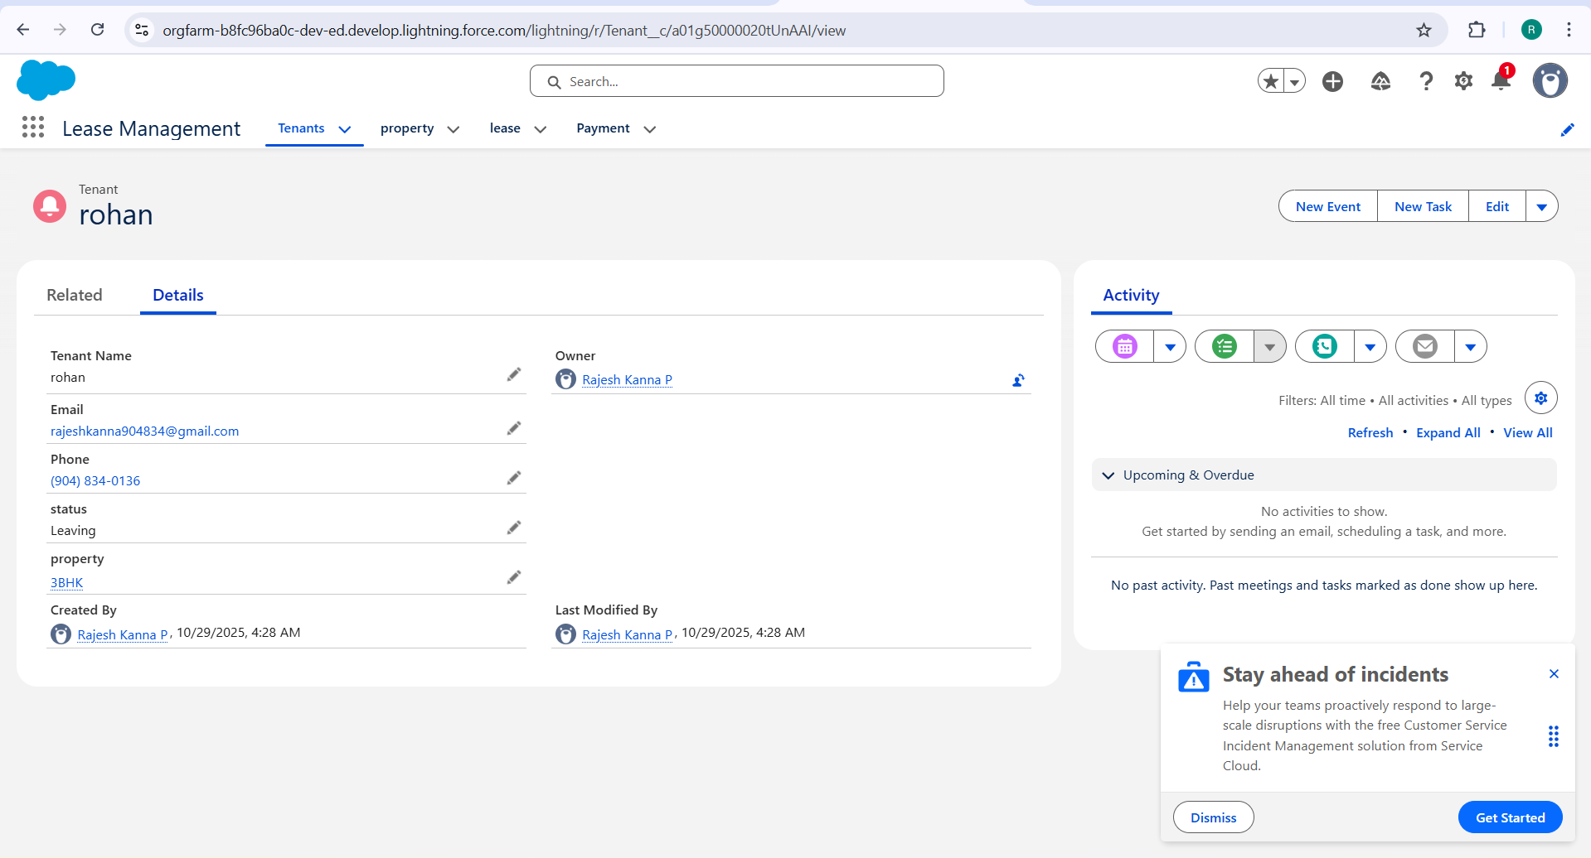
Principle | Purpose
Role-Based UI | Clerks see only assigned stores; Managers view all stock
Clean Layout | Streamlined tabs and record pages for faster navigation
Guided Navigation | Quick actions and flows for PO and GRN creation

3.2 Home Page Design
Component | Purpose
Quick Action Flow | “Create Purchase Order” – one-click procurement initiation
Dashboard View | Displays stock level summary, low-stock alerts, and expiry data
Announcement Panel | Shows purchase approvals, vendor updates, and maintenance alerts

4. Automation Design
Automation minimizes manual intervention for stock updates, reorder alerts, and validation checks.
4.1 Screen Flow – Lease Creation Flow
Flow Steps:
- Select Purchase Order
- Display linked items with ordered quantity
- Enter received quantity, batch number, and expiry date
- Auto-update Stock Ledger and PO status to “Received”
- Show success confirmation — “Goods Received Successfully”
Outcome:
- Eliminates manual stock entry
- Ensures accurate GRN tracking and stock updates
4.2 Apex Trigger – Auto Stock Update
Trigger on: GRN Line Item Object:

IF (Status__c == 'Received') {
Item__r.Current_Stock__c += Quantity_Received__c;
}

Trigger Event | Action
Before Insert / Update | Auto-update stock quantity at item level

Benefit:
Ensures real-time stock availability without manual adjustments.
5. Security Design
5.1 Profile-Based Access
Profile | Access Level
Store Clerk Profile | Create/Edit GRNs, Issues, Returns for assigned store
Inventory Manager Profile | Full CRUD on Items, Purchase Orders, GRNs
Finance Officer Profile | Read-only on stock, full access to purchase data
System Admin | Complete access and configuration control

5.2 Sharing Rules
Rule | Shared With | Purpose
Item.Stock_Status = "Low" | Inventory Manager | Automatically notifies managers to initiate the reorder process when stock levels drop below threshold.
GRN.Status = "Received" | Store Clerk & Finance | Enables both store clerks and finance users to update stock records and verify purchase completion.
Expiry_Date ≤ 30 Days | Store Clerks | Triggers alerts and restricts issue of near-expiry items to ensure patient safety and regulatory compliance.

Security Highlights:

- Ensures restricted access per user role
- Provides 360° visibility for management

6. Reporting and Dashboard Design
6.1 Reports Created
Report Type | Purpose
Item with Stock Ledger | Monitor real-time stock levels
Purchase Order with GRN | Track procurement efficiency
Near-Expiry Item Report | Proactive expiry control
Department Issue Summary | Analyze consumption trends

6.2 Dashboard Components
Component | Visual Type | Insight
Stock Overview | Donut Chart | Current stock by category
Expiry Summary | Bar Chart | Items expiring in next 30 days
Top Vendors | Line Chart | Vendor performance trends
Low-Stock Alerts | Table | Items below reorder level
Monthly PO Trends | Area Chart | Procurement cycle analysis

7. System Architecture Design
Layer | Component | Purpose
Presentation Layer | Lightning App UI | User interaction & operations
Logic Layer | Flows, Apex Triggers, Validation Rules | Automates core inventory processes
Data Layer | Custom Objects | Stores items, suppliers, and transactions
Analytics Layer | Reports & Dashboards | Provides insights & performance metrics

8. Design Constraints
Constraint | Impact | Solution
Large stock dataset | Slow dashboard refresh | Use summarized reports
Multiple alerts | User fatigue | Combine alerts into daily digest
Mobile layout scroll | Minor usability issue | Enable responsive page templates

9. Future Design Considerations
Enhancement | Benefit
Supplier performance analytics | Evaluate vendor efficiency
Barcode/QR integration | Speed up item receipt & issue
IoT-based auto-reorder sensors | Real-time inventory automation
AI-powered demand forecasting | Reduce overstock and wastage

10. Summary
The Project Design Phase establishes the structural, functional, and visual foundation of the Medical Inventory Management System.
Through Salesforce Lightning design, automated flows, secure access, and real-time dashboards, the system ensures:
- Fully automated stock and procurement lifecycle
- Simplified, user-friendly interface for non-technical staff
- Role-based security for compliance and control
- Comprehensive reporting for informed decision-making
This design enables a seamless transition to the Implementation & Testing Phase, ensuring that the solution is ready for deployment in a healthcare environment.

